New Patients | 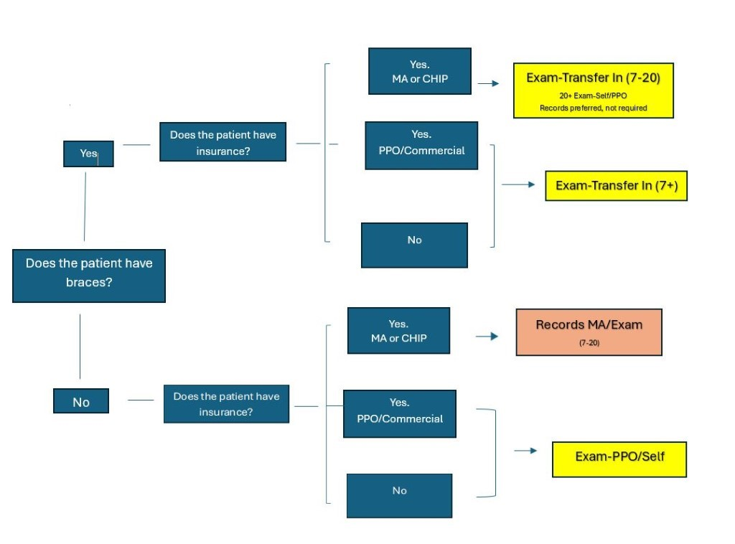  - Do not schedule exams side by side for siblings, couples, families.  - Observation appointments are a type of exam defined as: follow up consultations for both Medicaid and Self Pay patients when recommended by the Orthodontist.  - Age Minimum: 7 years old (unless patient has a referral from their dentist)

